Identified Design Patterns

* Pedro Catarino 60597:
  + Pattern 1 – Template Method
    - **Illustrating code snippet:**

On *ChartComponentBase*:

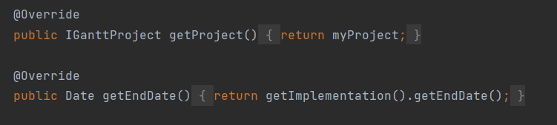

Methods with the same implementation

Methods with different implementation

On *GanttGraphicArea*:



On *ResourceLoadGraphicArea:*



* + - **The exact location on the codebase:**

Project > ganttproject > src > main > java > net > sourceforge > ganttproject > ChartComponentBase, GanttGraphicArea, ResourceLoadGraphicArea

* + - **An explanation of the rationale for identifying this as a pattern instantiation:**

*GanttGraphicArea* and *ResourceLoadGraphicArea* have a similar implementation that they share with the abstract class *ChartComponentBase,* the difference in their implementation is done in each of the subclasses.

* + Pattern 2 – Singleton
    - **Illustrating code snippet:**

****Instantation:

Lazy construction:

* + - **The exact location on the codebase:**

Project > biz.ganttproject.core > src > main > java > biz > ganttproject > core > time > GanttCalendar

* + - **An explanation of the rationale for identifying this as a pattern instantiation:**

There is only one instance of this class and it is responsible for itself.

* + Pattern 3 – Memento:
    - **Illustrating code snippet:**

* + - **The exact location on the codebase:**

Project > ganttproject > src > main > java > net > sourceforge > ganttproject > undo > UndoableEditImpl

* + - **An explanation of the rationale for identifying this as a pattern instantiation:**

Redundant method.